Andrew McClelland, Rony Besprozvanny and Ryan Fredrickson

KtCS admin manual

# Generate Monthly Invoice for User

1. On the Admin Homepage under the Monthly Invoice section select the user and month you would like to generate the invoice for, click submit.

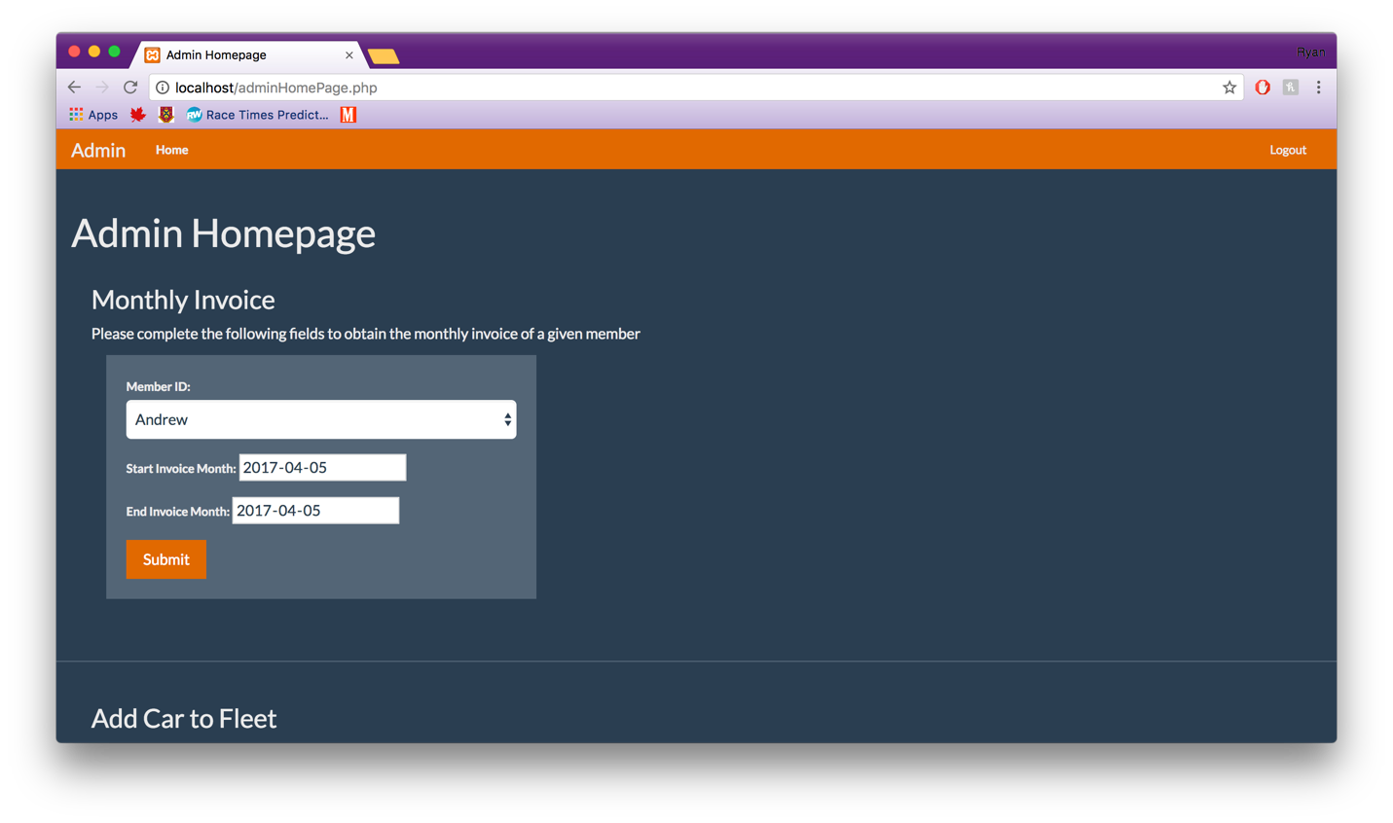

# Add a Car to Fleet

1. Go to the add car button and click it to launch into the form.

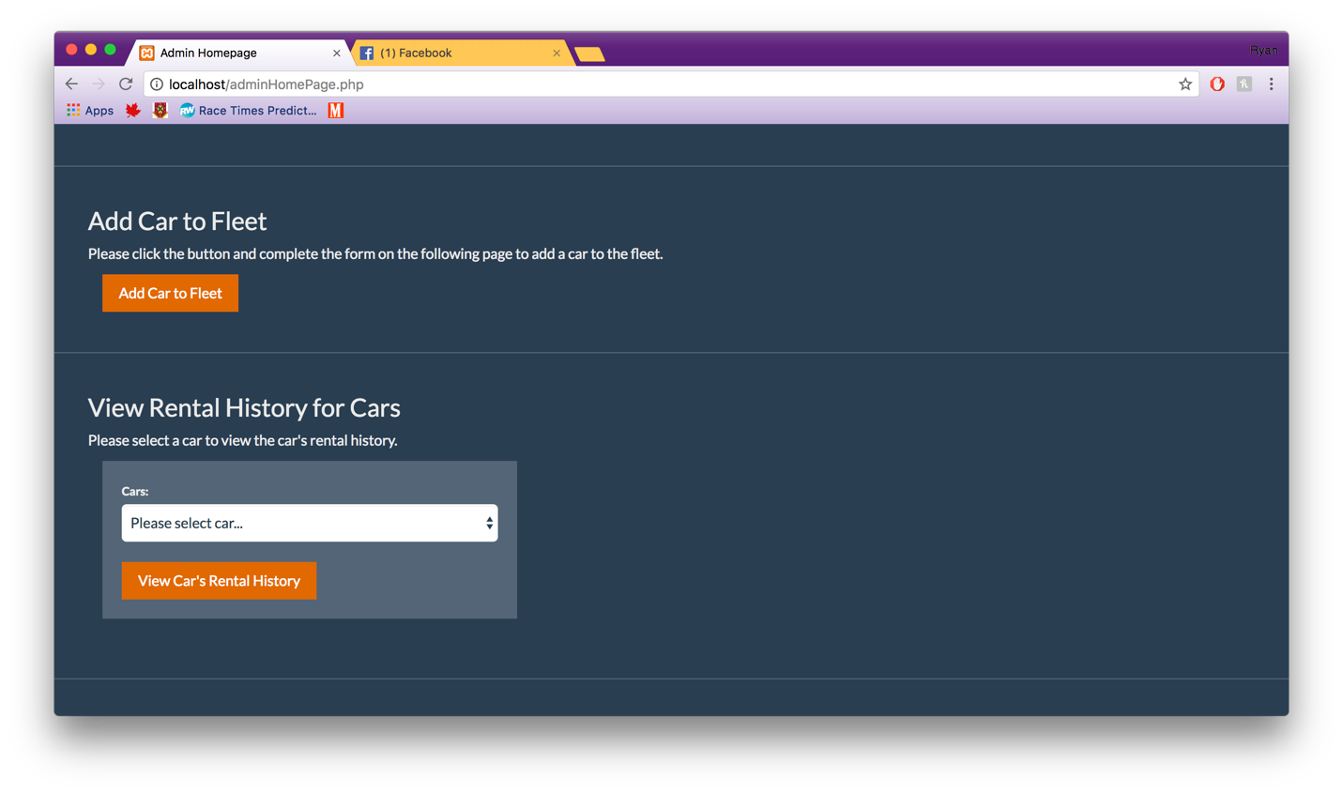

1. Fill in the form and click submit when new car is ready to be added.

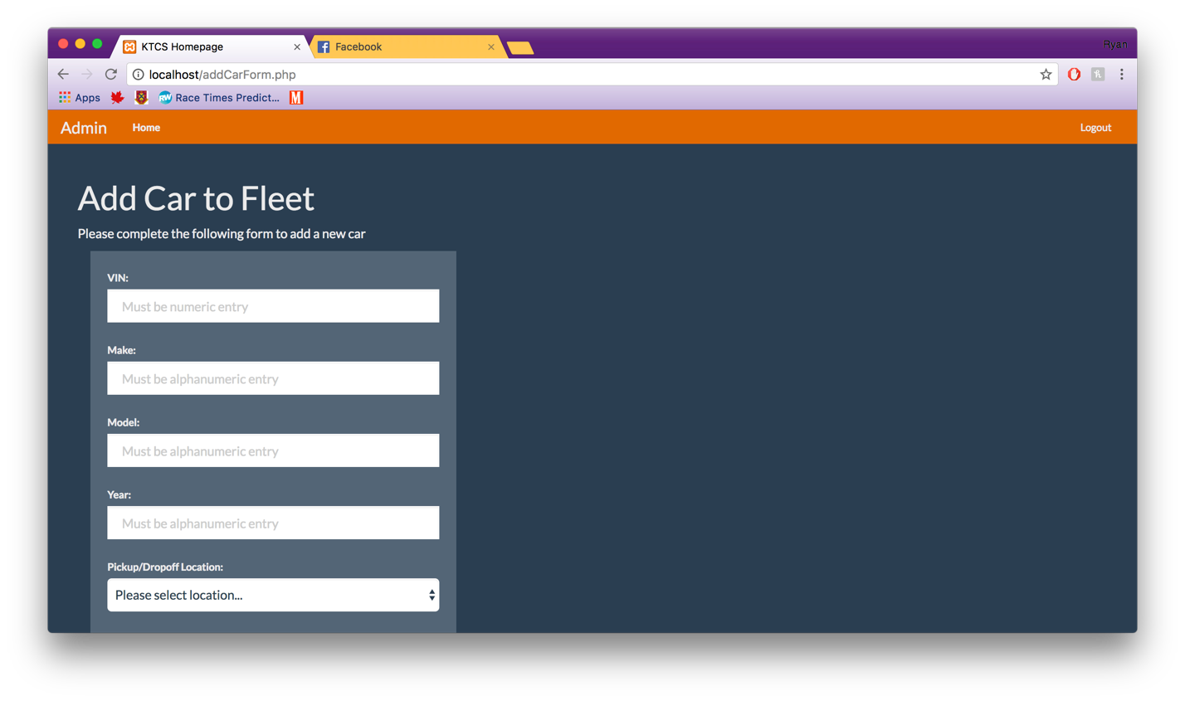

# Show Rental History for Car

1. On the Admin Homepage under the View Rental History for Cars section select the car you would like to history for, click View Car’s Rental History.

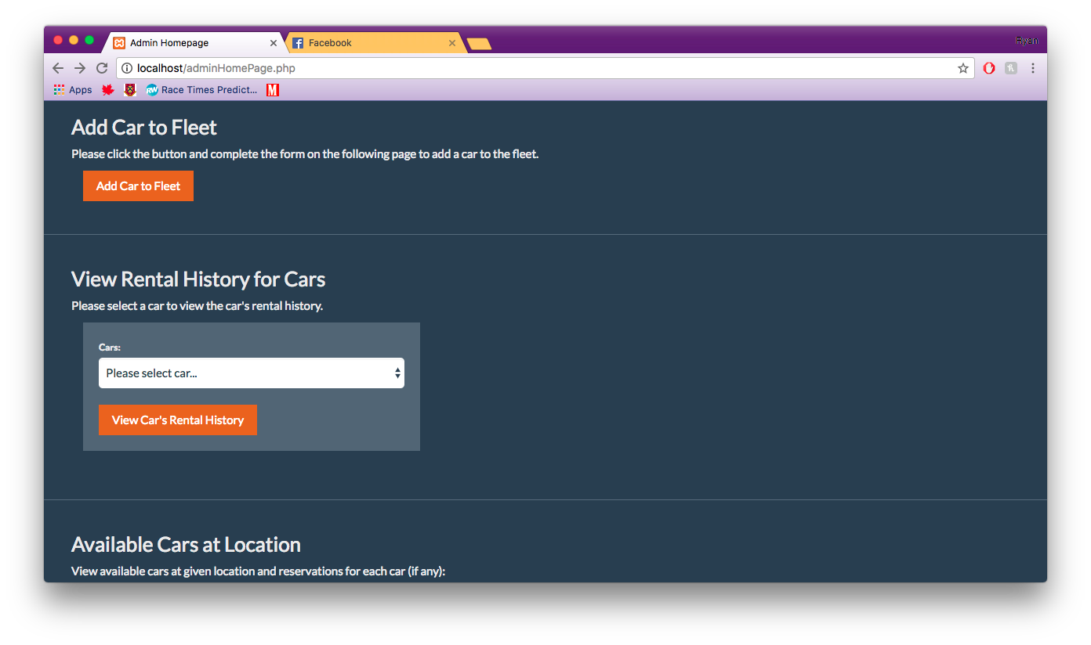

# Show Cars at Location

1. On the Admin Homepage under the Available Cars at Location section select the location you would like to find the cars for, click Submit.

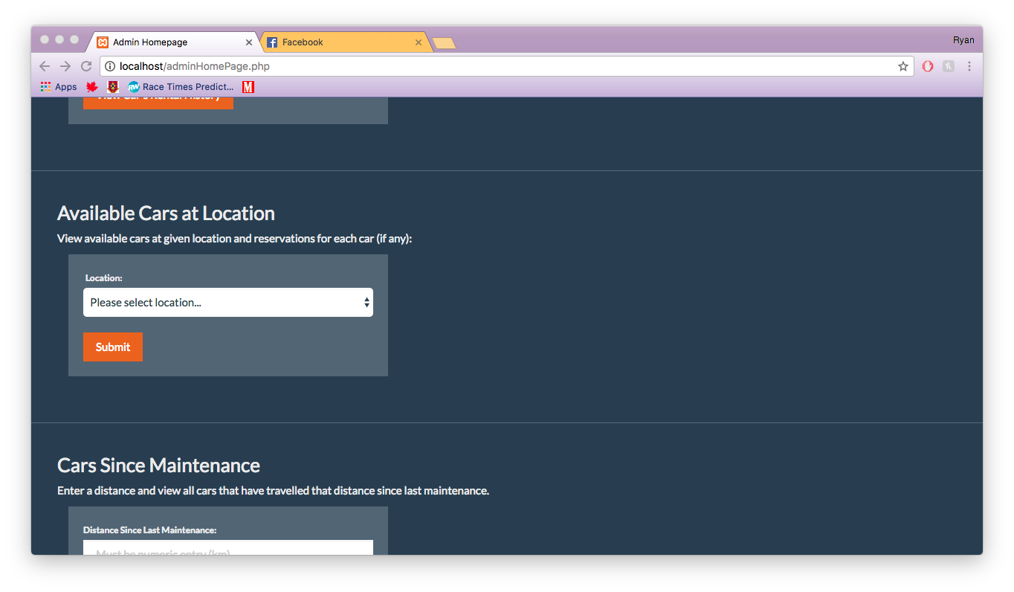

# Show Cars with Distance Since Maintenance

1. On the Admin Homepage under the Cars Since Maintenance section enter the amount of kilometers you would like to see the cars for, click View Specified Cars.

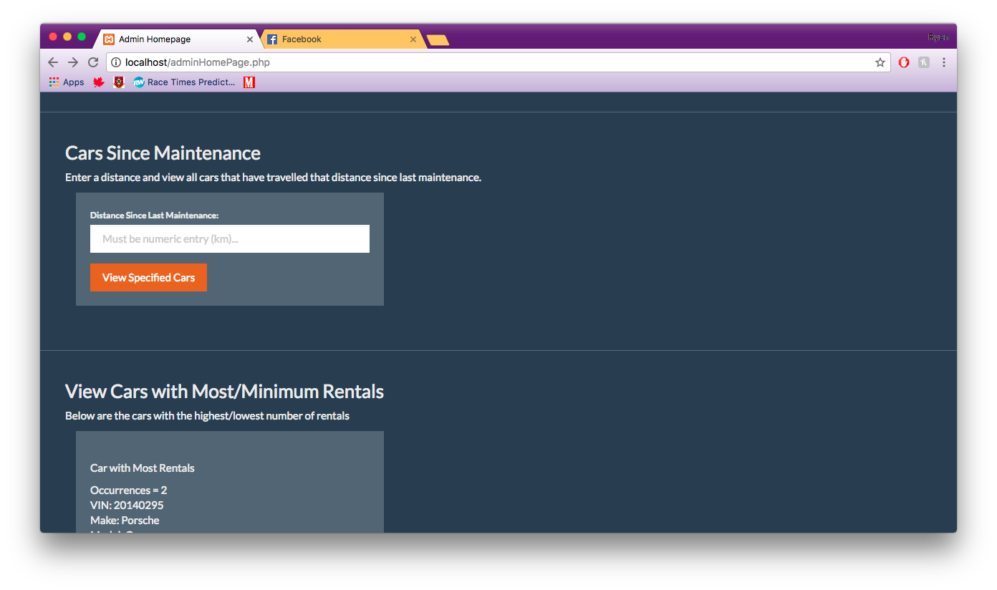

# View Cars with the most and least number of rentals

1. On the Admin Homepage under the View Cars with Most/Minimum Rentals there will be the two cars.

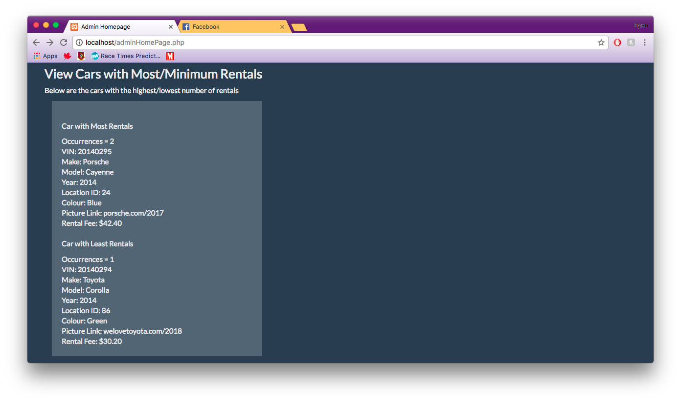

# Generate Monthly Invoice for User

1. On the Admin Homepage under the View Damaged/Need Repair Cars, click the button.

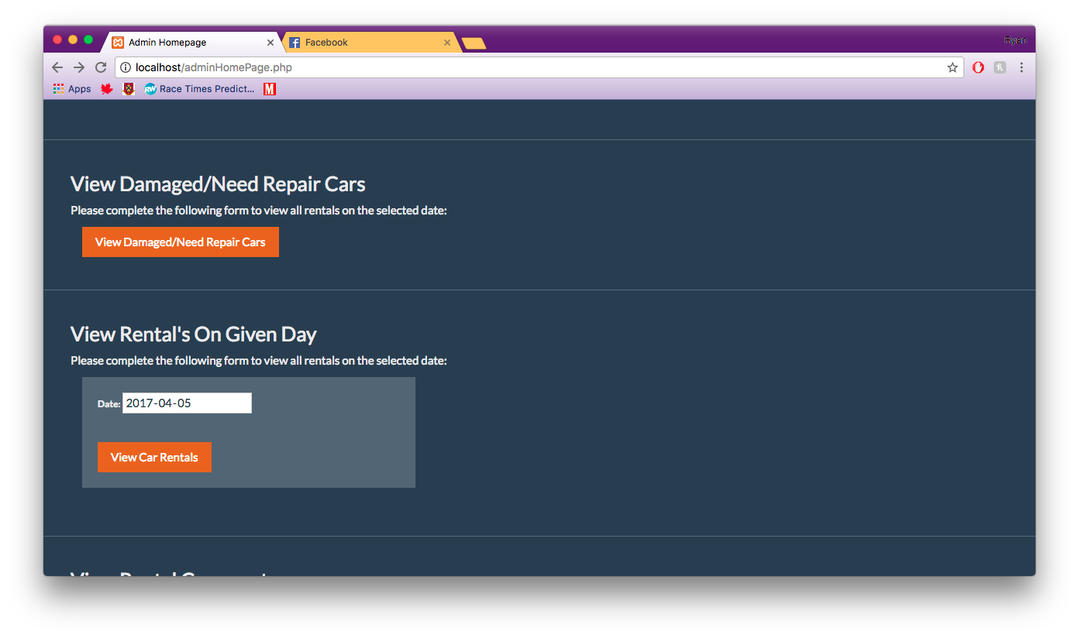

# Show all Reservations on a Day

1. On the Admin Homepage under the View Rental’s on a Given Day section enter the day you would like to see the cars for, click View Car Rentals.

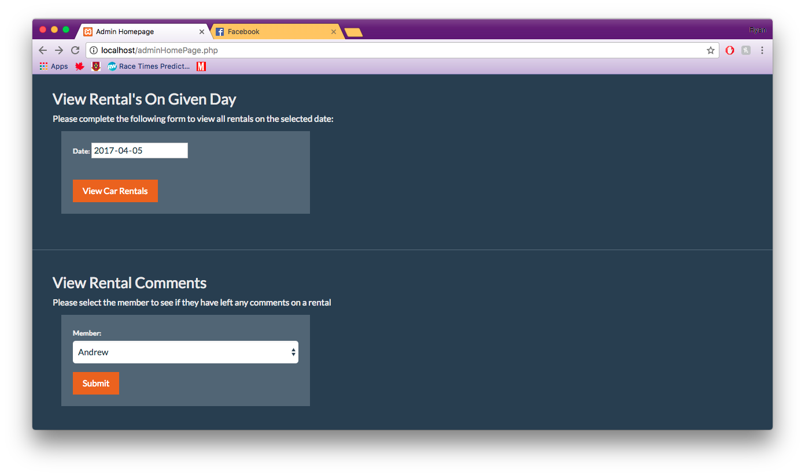

# Respond to a Members Comment

1. On the Admin Homepage under the View Rental Comments section enter the the user you would like to respond too, click click Submit.

